

Eproject

**Web Designing**

**BAGBAG**

|  |  |
| --- | --- |
| **Authors** | **C1812G - Group Aptech C1812G** |
| 1. NGO VU THANH TOAN-Student1166641  (Leader) 2. PHAM HUU LOI - Student1165160 3. DOAN LE NHA TUAN - Student1179209 4. NGUYEN MINH HUNG - Student1144194 |
| **Centre Name** | Aprotrain Aptech |
| **Date** | 18th ,November 2019 |
| **Semester** | 1 |
| **Instructor** | TRUONG NGOC KHAC NGUYEN |

**HCM City, 21th November 2019**

**CATEGORY**

**PREFACE**

**HEADING ………………………………………………………………….………….** 2

**CHAPTER I: OVERVIEW …….………………………………………….….....** 2

* 1. Introduce the topic ....................................................................... 3
  2. Sitemap
  3. Purpose of website ...................................................................... 3
  4. Some main pages ........................................................................ 3

**CHAPTER II: ANALYSIS EPROJECT**

1. Functional Requirement ................................................................ 3

**CHAPTER III: EPROJECT DESIGN**

1. Design Eproject by DFD

* Define DFD
* Analysis
* Design
* Communication
* Document
* The main Component of Context Diagram
* The process: shows the common function of system
* DFD Level 0: Context Diagram
* DFD Level 1: Customer
* DFD Level 1.1:
* DFD Level 1.2:
* DFD Level 1.3:
* DFD Level 2.0: Admin

1. Design FlowCharts

* Login
* Register
* Order
* Search
* Upload

**CHAPTER IV: INTERFACE SNAPSHOT**

* Home Page
* Categories Page
* About Us Page
* Gallery Page
* Contact Us Page
* Cart Page
* Forget Password Page
* Login Page
* Profile Page
* Register Page
* Single Page

**CHAPTER V: USER GUIDE**

1. Home Page
2. Categories Page
3. About Us Page
4. Gallery Page
5. Contact Page

**CHAPTER VI: ADMIN GUIDE**

1. SiteMap
2. Details of Pages
3. Login Page
4. Home Page
5. Category Manager
6. Products Manager
7. Customer Manager
8. Gallery Manager
9. Order

**PREFACE - Done**

Today, information technology has developed strongly following width and depth. Electronic computers are no longer a rare medium is becoming more and more a popular tool for children to work and play people, not only in the workplace but also in the family. Especially public Information technology is applied in all fields of economics, politics, society ... Applications Information technology and computerization are considered one of the decisive factors set in national, organizational and in-store operations. It plays the role The game is very important and can create a powerful breakthrough.

The INTERNET network is one of the most valuable and great products become an indispensable tool, the foundation for transmission and exchange global information. By INTERNET, we have done the merits The faster speed, much lower cost than the traditional way. This, in turn, promotes the birth and development of e-commerce around the world, significantly altering the cultural face, improving people's lives. In production and business activities, the typical trade has been confirmed to be exposed advancing and promoting the development of enterprises. For a company, advertising promote and introduce products to customers to meet increasing shopping needs Customer's will be necessary. Therefore, our group has carried out the topic "Building Website development for showing the information about products available in Website”. This website will be the place where people can get all information about various products available with them easily.

The website is called COSY AIRCONDITIONER and will be the place where the company best promotes all the products they sell. Through this we would like to express our sincere thanks and express gratitude to you dedicated instruction of teachers in the school "Aptech international programmer training system". Especially Mr.Nguyen Ngoc Khac Nguyen, who directly instructed, taught and helped us during the implementation of this project.

**CHAPTER I: OVERVIEW**

1. ***Introduce the topic: Đã chỉnh sửa***

Business - promoting is an indispensable need for each of company. In the current competitive era, the introduction of business products to individuals with low cost and high efficiency is a dilemma of business people with the demand for shopping with multi-products, Quality and affordability of consumers. So, our team conducted the website design to show product information online to help the company grow faster.

1. ***Sitemap:***

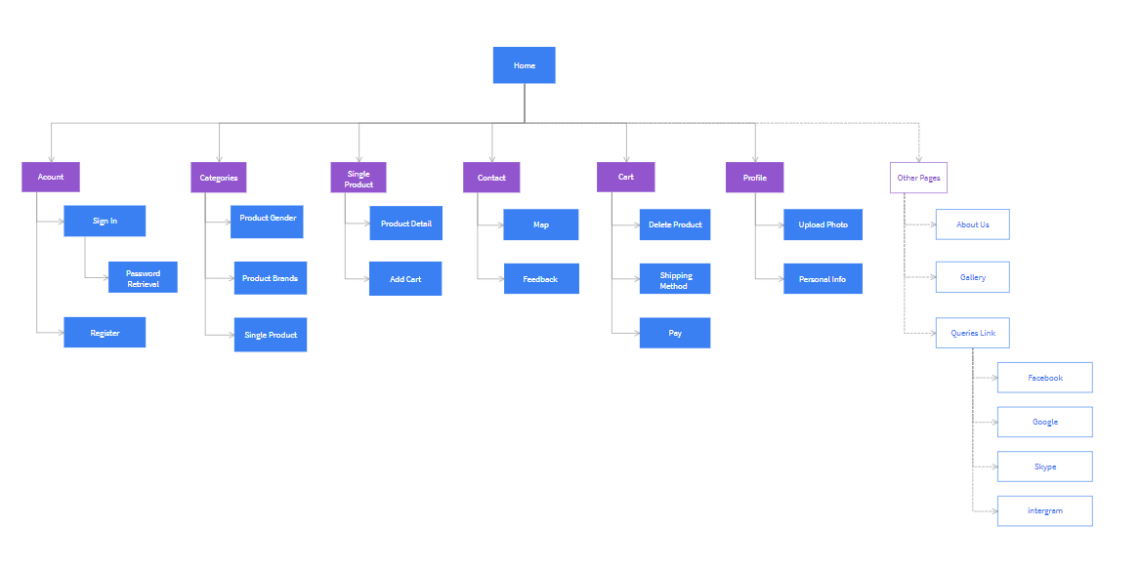

***3.* *Purpose of website: Đã chỉnh sửa***

The goal of the website is to introduce and promote the company and showing detail product infomation.The Air Conditioner that people care about. Customers know detailed information about products such as product name, price, specification infomation...

In addition, the website aims to introduce more known customers shopping, customers can contact to company to know more product’s information and make future purchases easier.

***4. Some main pages: Đang chỉnh sửa***

* **Home page**: This is an introduction page of the company's featured products. In addition, you can learn more about best product, top brand, best-selling pproduct, links to other pages of website, e-mail adress of company for customer’s contact and some outstand service of company. Đã chỉnh sửa
* **About page**: This is the customer page to view information about our company such as our misson, business strategy, our vision and some information if customer want to contact us. Đã chỉnh sửa
* **About us**: This page introduces customers with more information and collection of stores.
* **Library page**: This is the page containing shop collections.
* **Contact page**: This page displays the distance of customers coming to the company. This page contains company information for customers to contact Đã chỉnh sửa

**CHAPTER II: ANALYSIS EPROJECT**

1. ***Functional Requirement:***
2. The Home Page should be created making use of Sections with a suitable logo, the header section can be added which will show images of various Bags.
3. The site must contain the links to navigate through various types of Bags, BackPacks etc.
4. Site should have different section for Men and Women and bags should be placed accordingly.
5. Links of bags must be categorized like (Bags, Sling Bags, BackPacks etc.)
6. Specification and Pricing of Bags should be added along with the images.
7. Website should provide section for various brands offered in the store.
8. Gallery section should be added for viewing different images.
9. Feedback must be allowed to enter by the viewer
10. Site map, Gallery, about us, Queries link, Contact us link must be added. Show the location using maps or GeoLocation API
11. The complete description must be allowed to get download as pdf or doc file.
12. The advertise section with various facilities provided should be mentioned.

**CHAPTER III: EPROJECT DESIGN**

1. ***Design Eproject by DFD:***

* **Define DFD**

Data Flows Diagram (DFD) describes the information flow in the system. The next step of system analysis is to consider in detail the information necessary for the implementation for functions discussed above and the one necessary for the improvement of the functions. Modeling tool frequently used for this purpose is DFD. DFD will support 4 main activities.

* **Analysis**

DFD is used to determine requirement of users.

* **Design**

DFD is used to map out plan and illustrate solution to analysis and users while designing a new system.

* **Communication**

One of the strength of DFD is its simplicity and ease to understand to analysts and users.

* **Document**

DFD is used to provide special description of requirement and system design. DFD provide an overview of key functional components of the system but it does not provide any detail on these components. We have to use other tools like database dictionary, process specification to get and idea of which information will be exchanged and how.

* **The main Component of Context Diagram:**

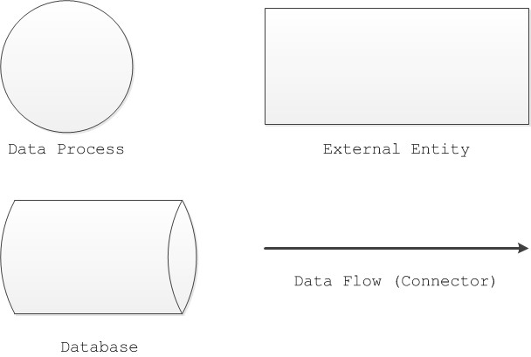

* **The process: Shows the common function of system**













1. ***Design FlowChart:***

* ***Login:***



* **Register:**



* **Order:**



* **Search:**



* **Upload:**



**CHAPTER IV: INTERFACE SNAPSHOT**

* **Home Page: Đã chỉnh sửa**

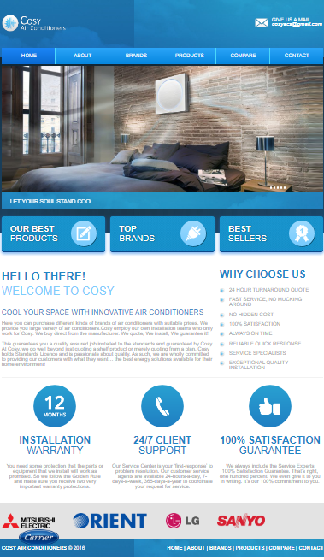

* **Categories Page:**

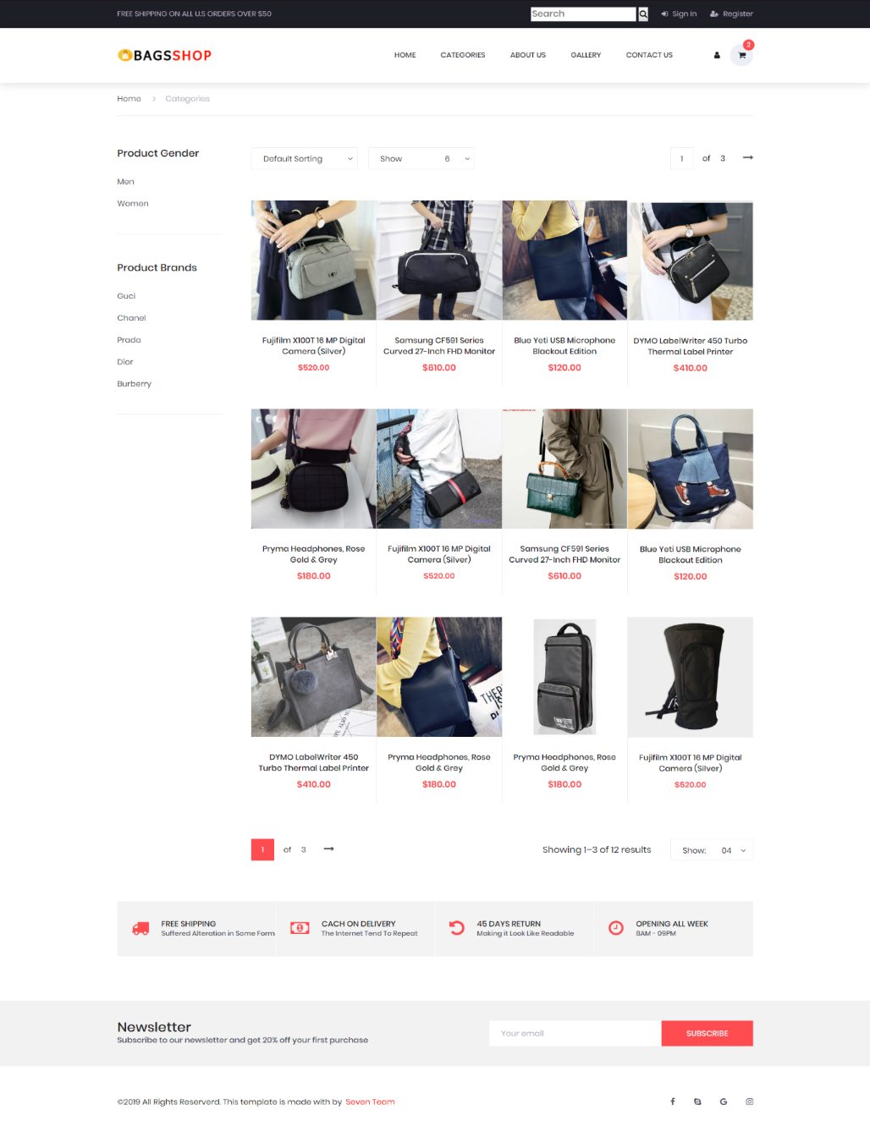

* **About Page:**

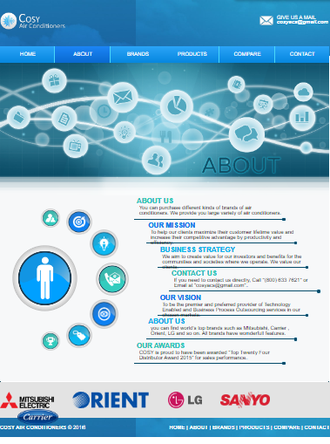

* **Gallery Page:**

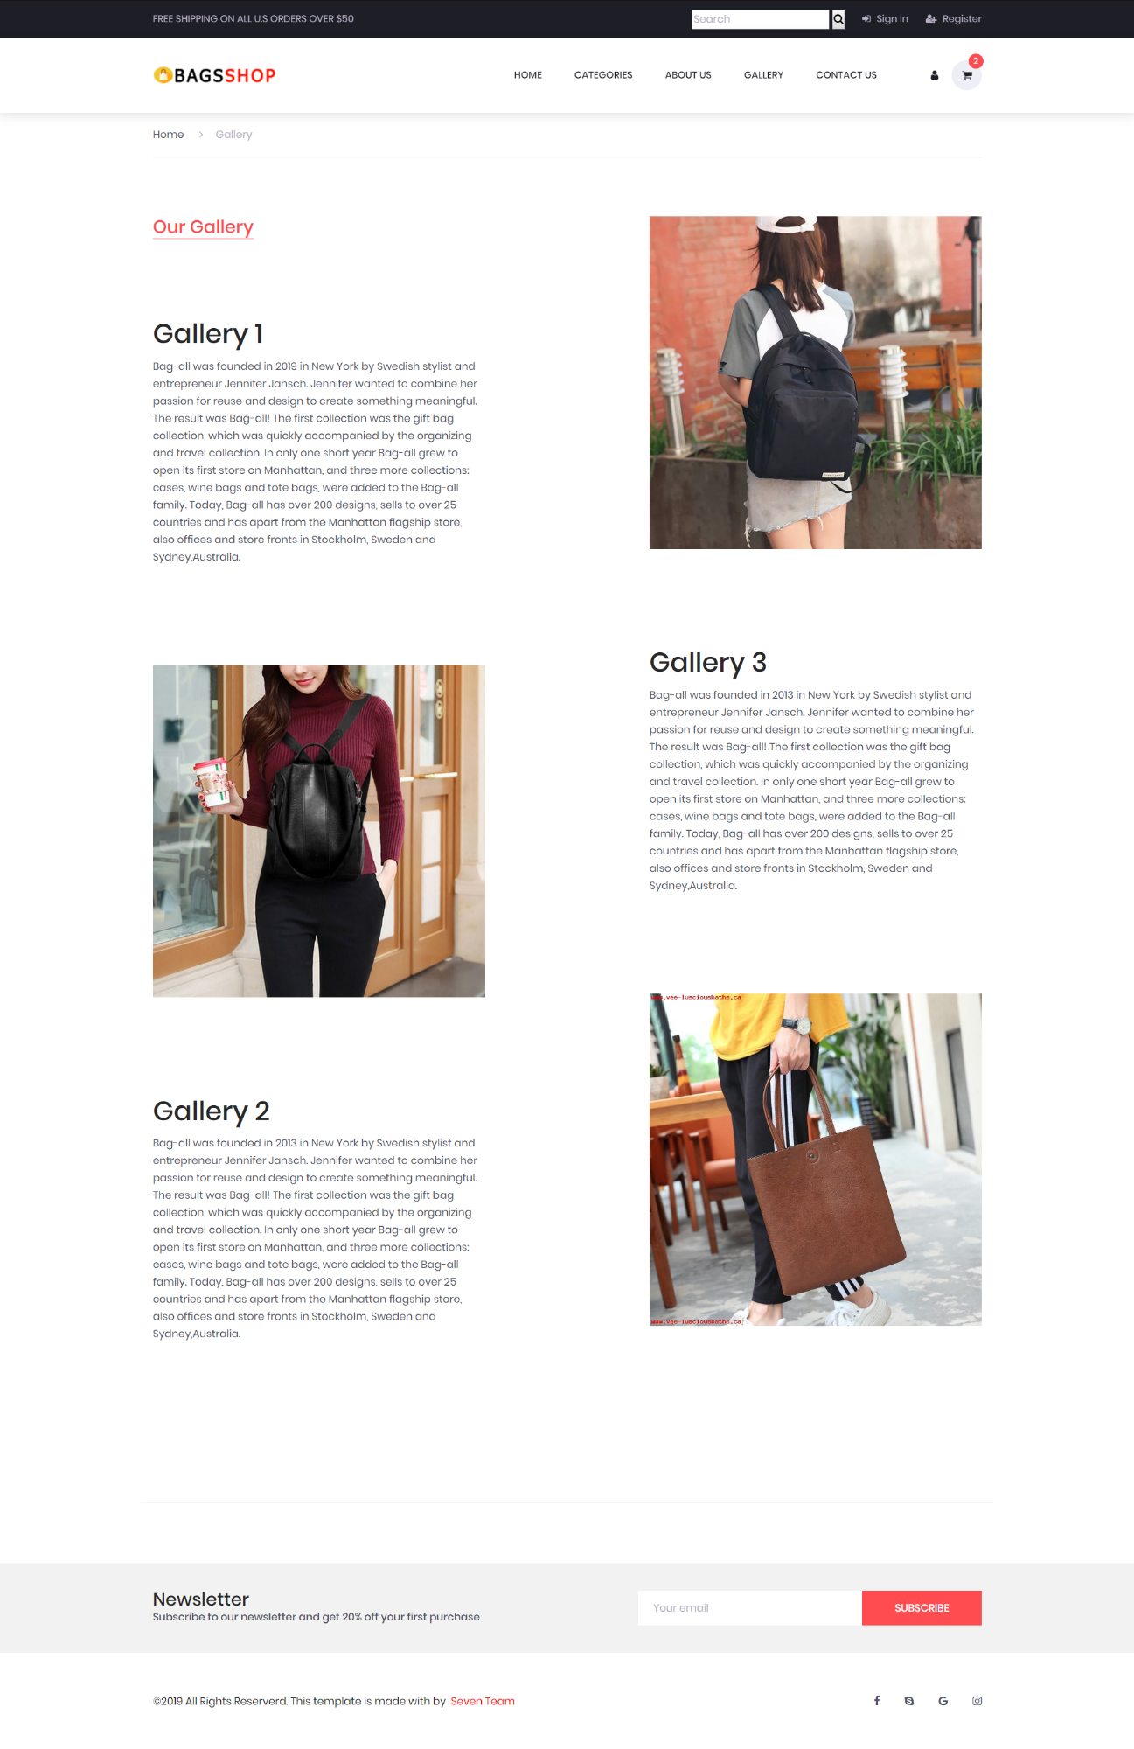

* **Contact Us Page:**

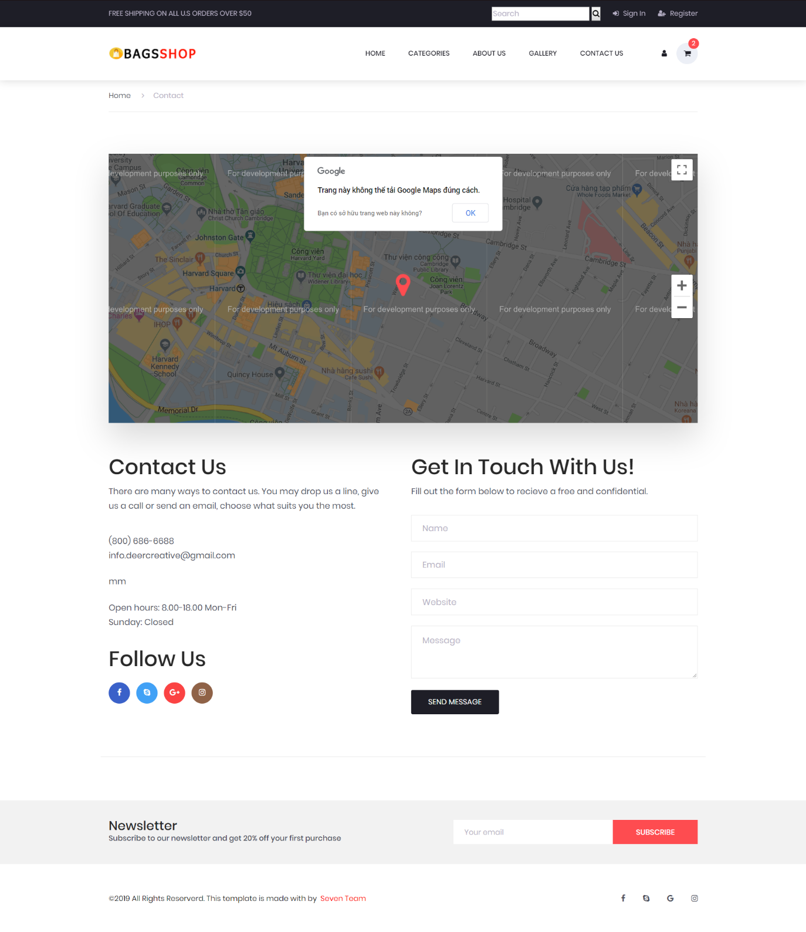

* **Cart Page:**

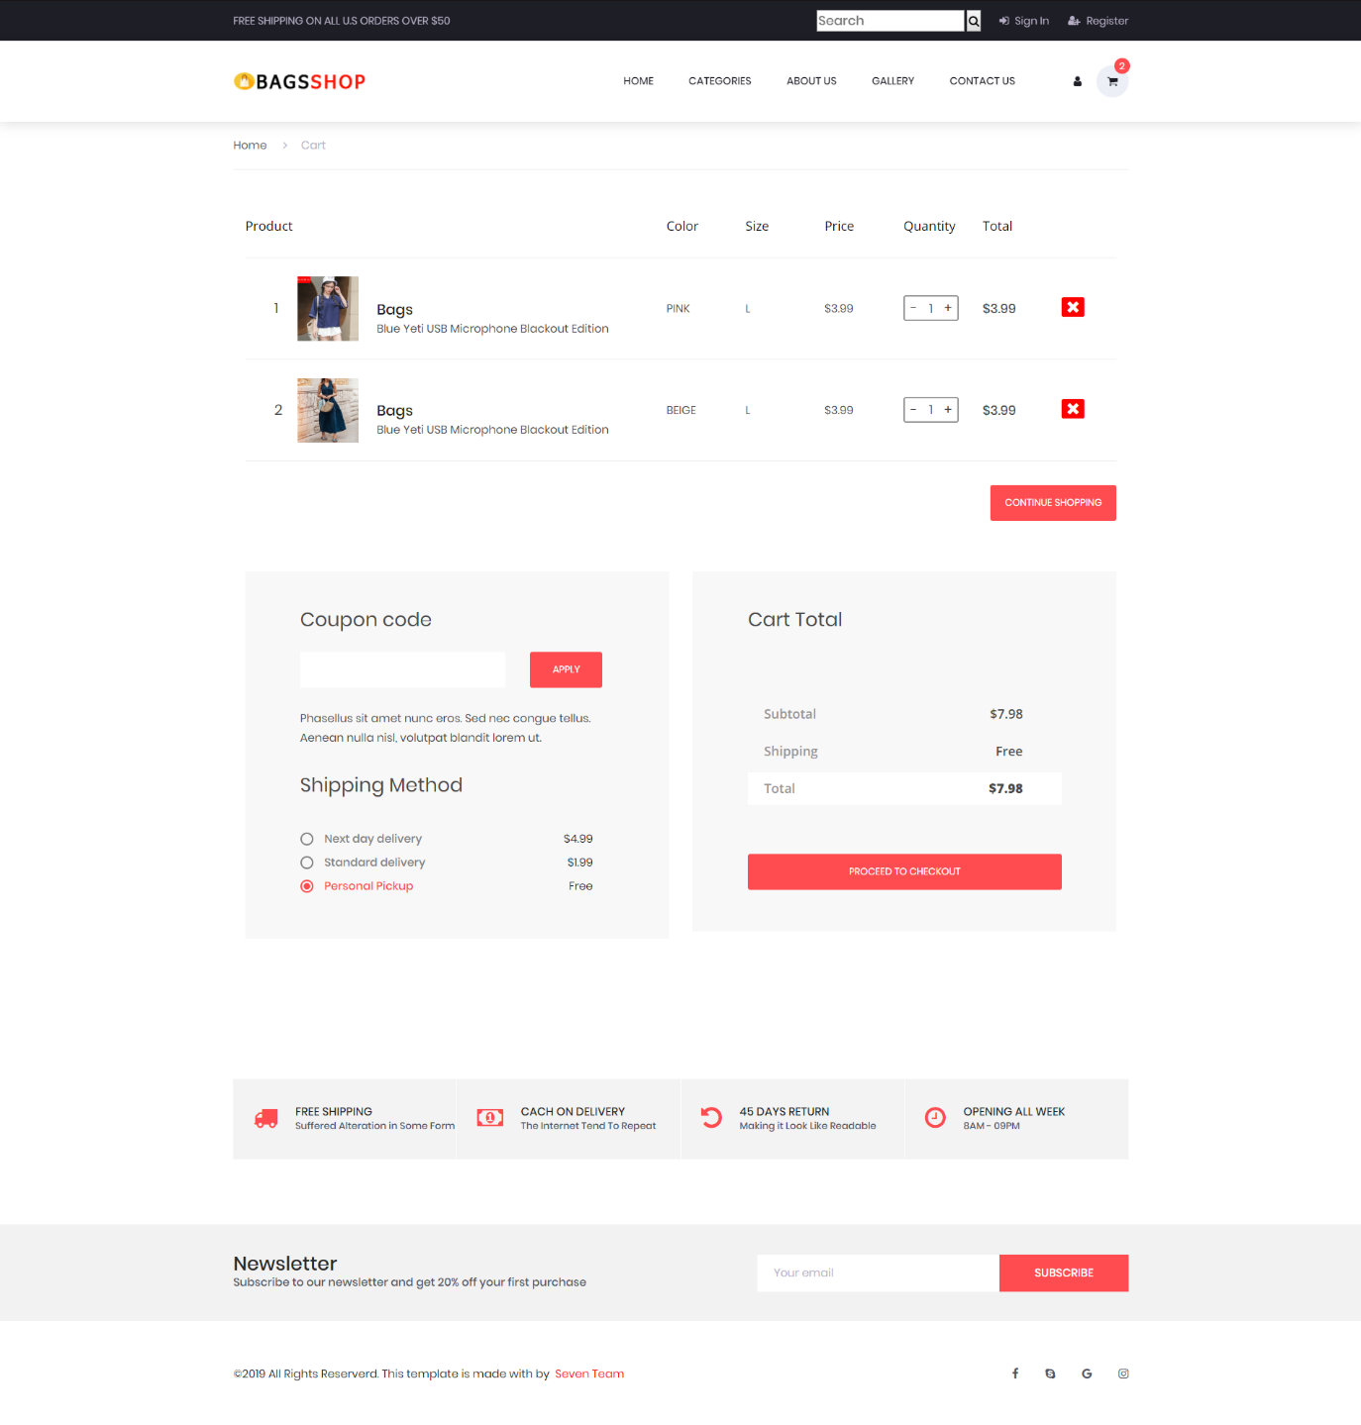

* **Forget Password Page:**

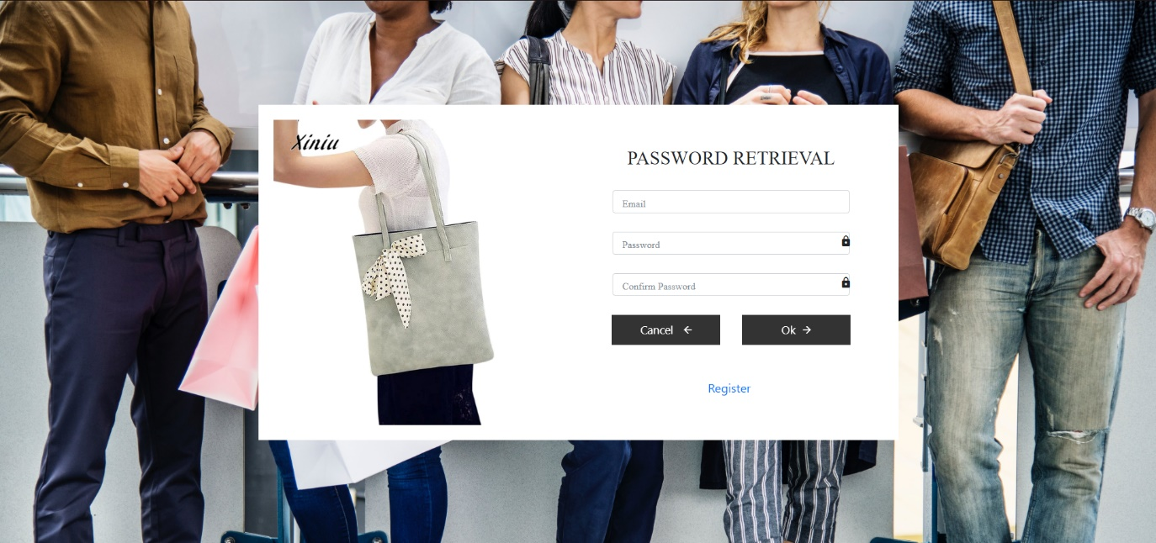

* **Login Page:**

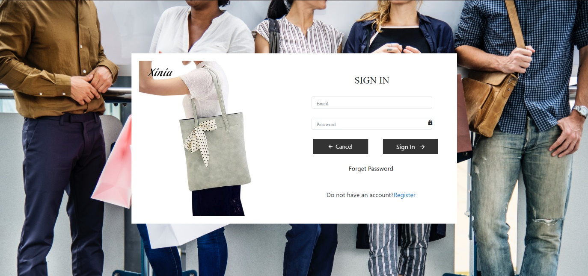

* **Profile Page:**

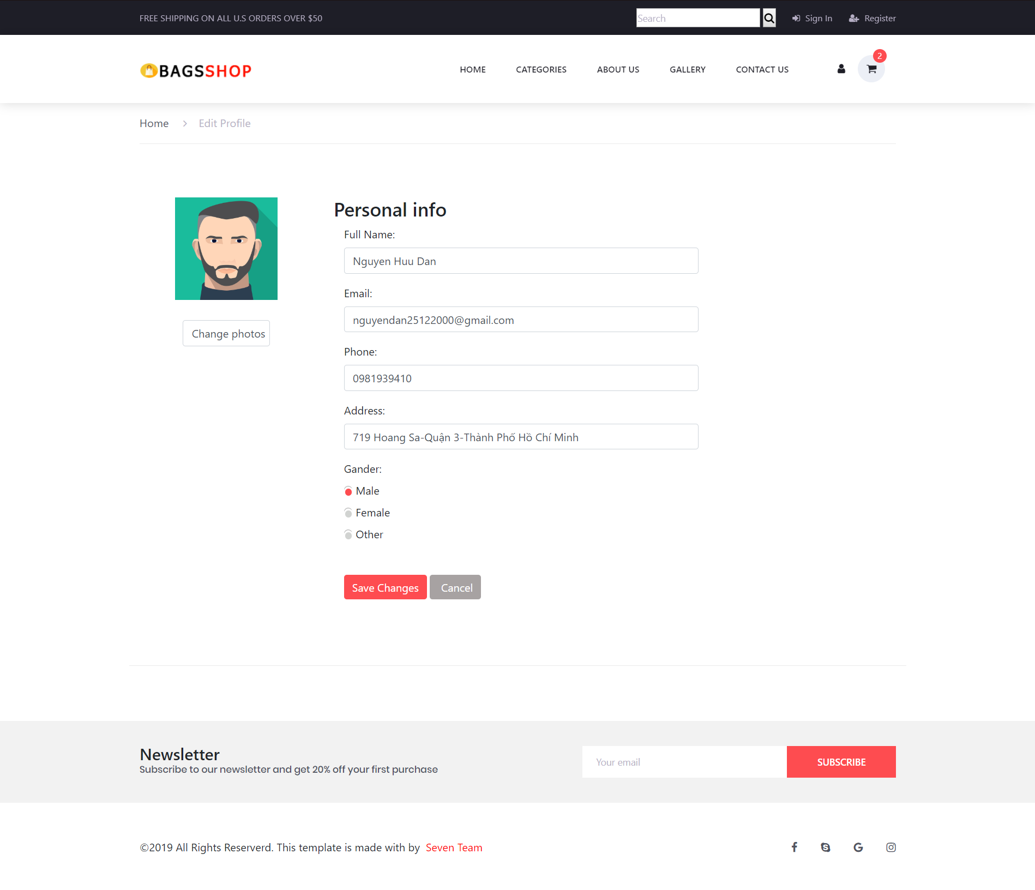

* **Register Page:**

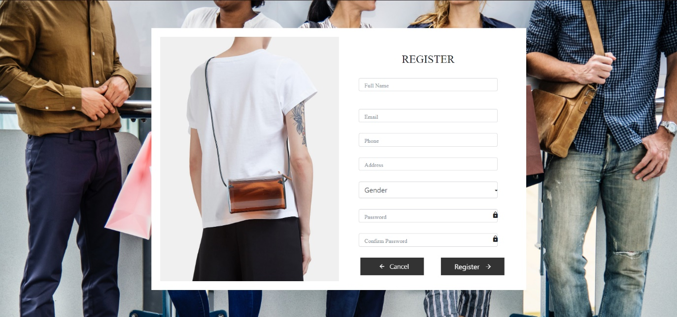

* **Single Page:**

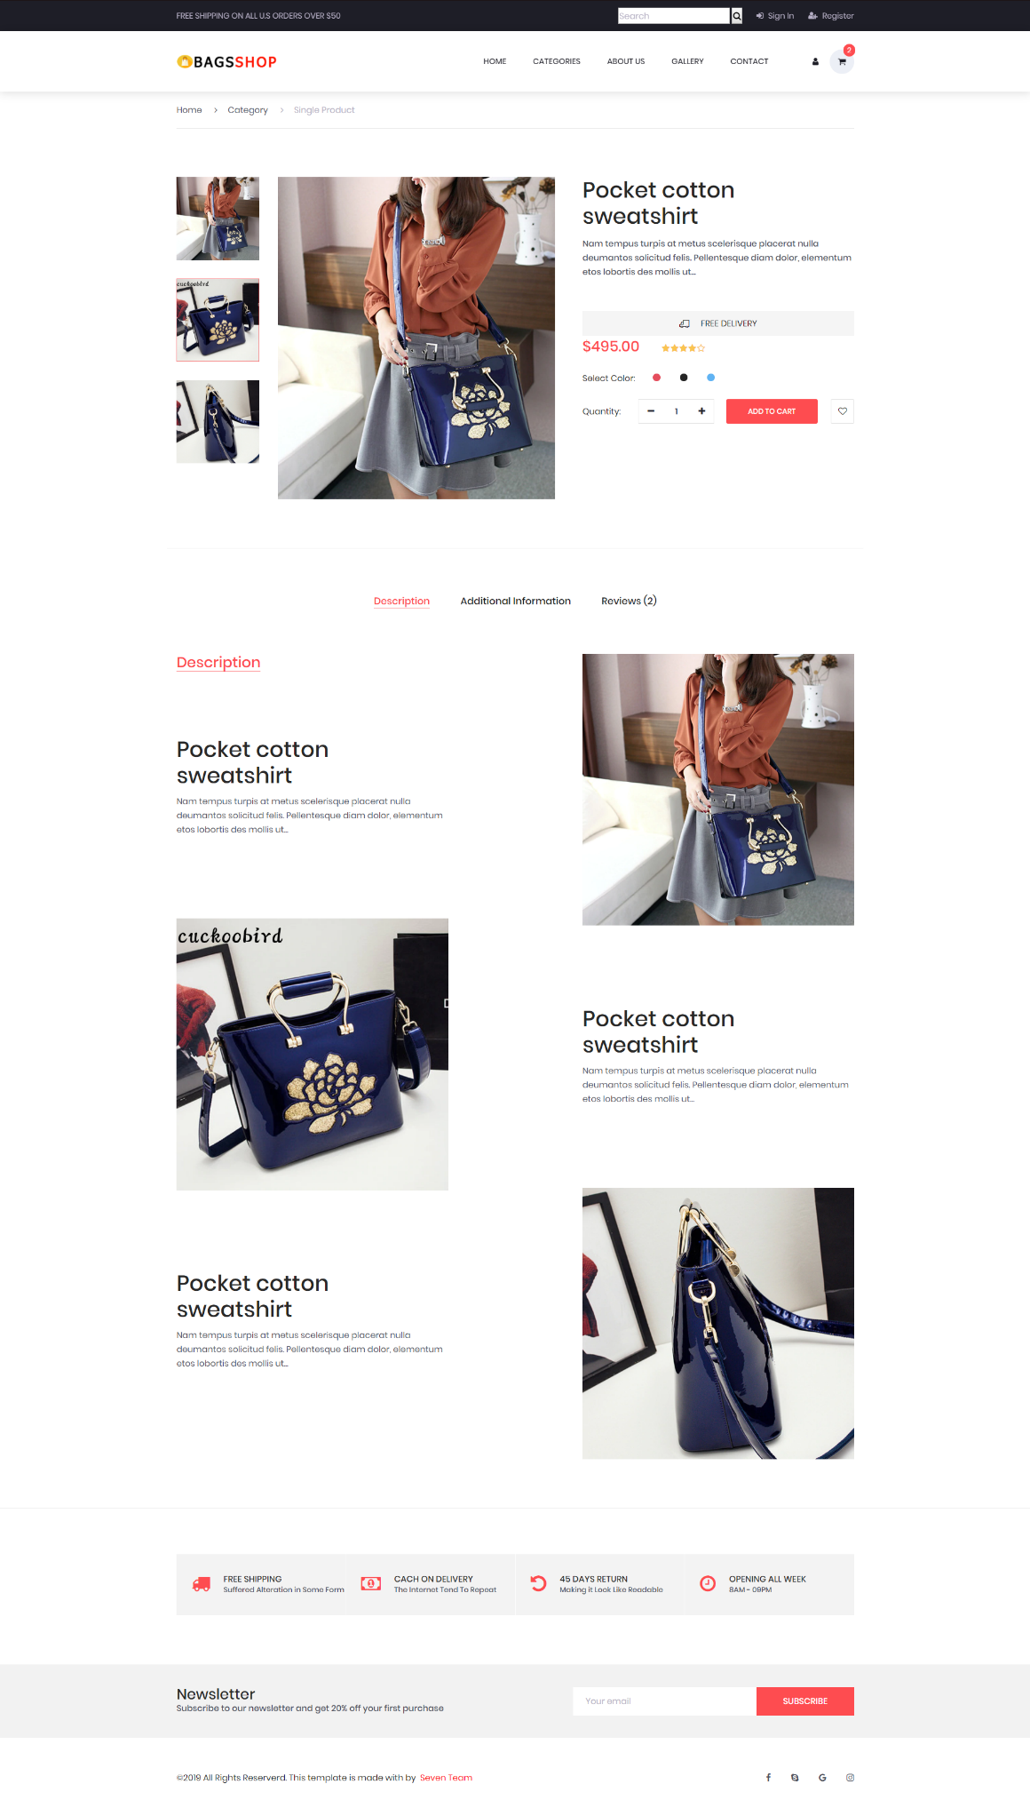

**CHAPTER V: USER GUIDE**

1. **Home page:**
2. **Content:** The Home page of the website includes the following information:

* Brief introduction to the website: shop promotion, the corresponding customers and products, promotion period remaining, the best selling products, collection.

1. **Form:**

* **The Welcome Page:**

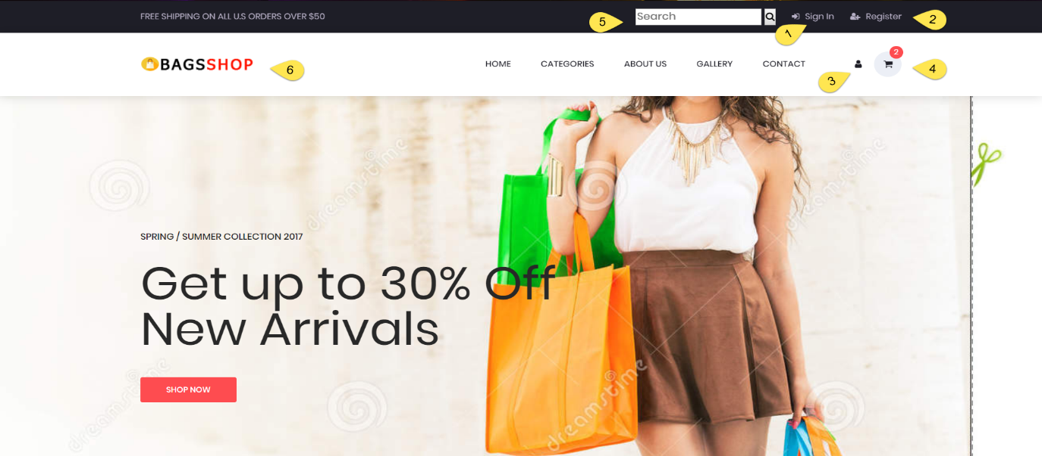

* **The Login Page:**

: Customers can login to their account when clicking here:

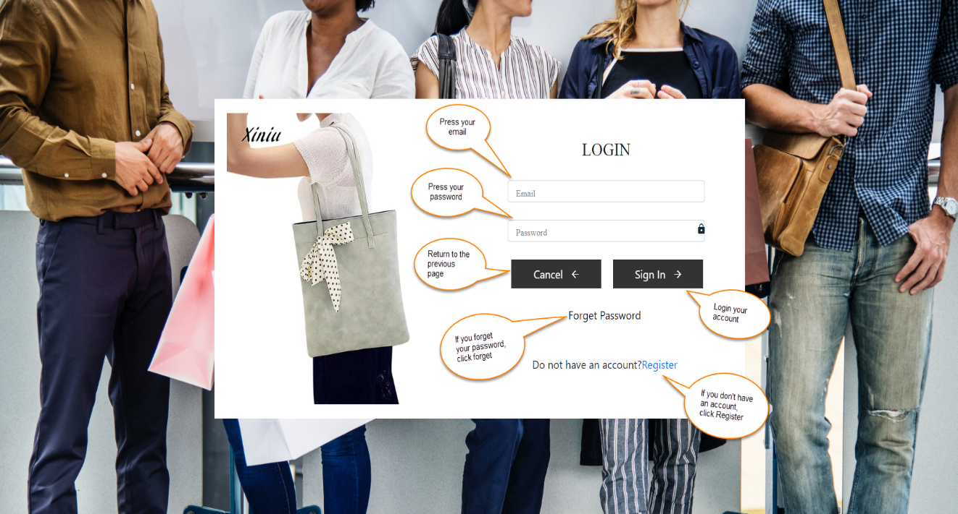

Example:

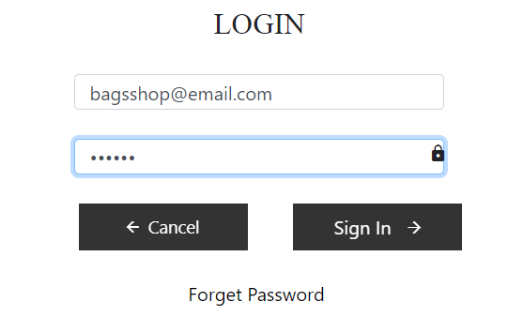

If the customers forgets the password , click Forget Password:

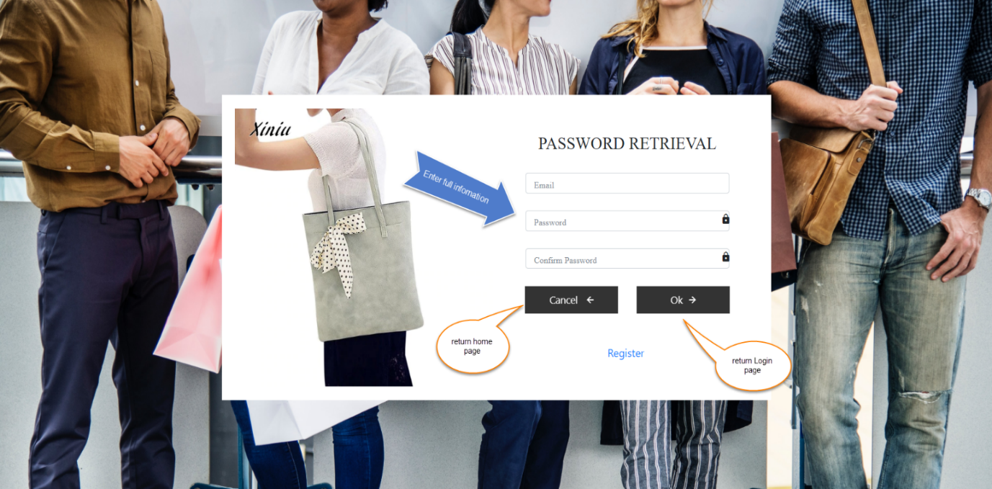

* **The Register Page:**

 : Customers can register a new account here:

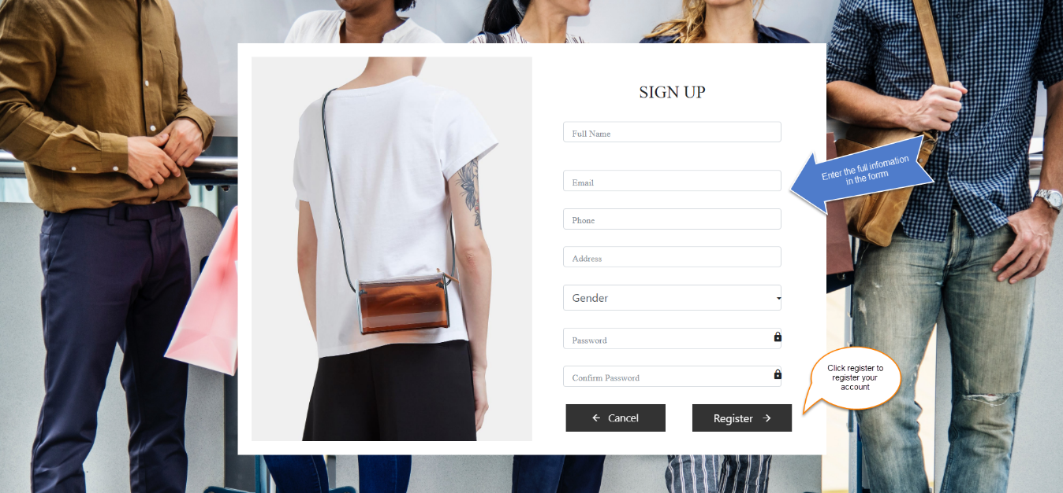

* **The Profile Page:**

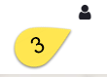: Customer can view their account information when click here

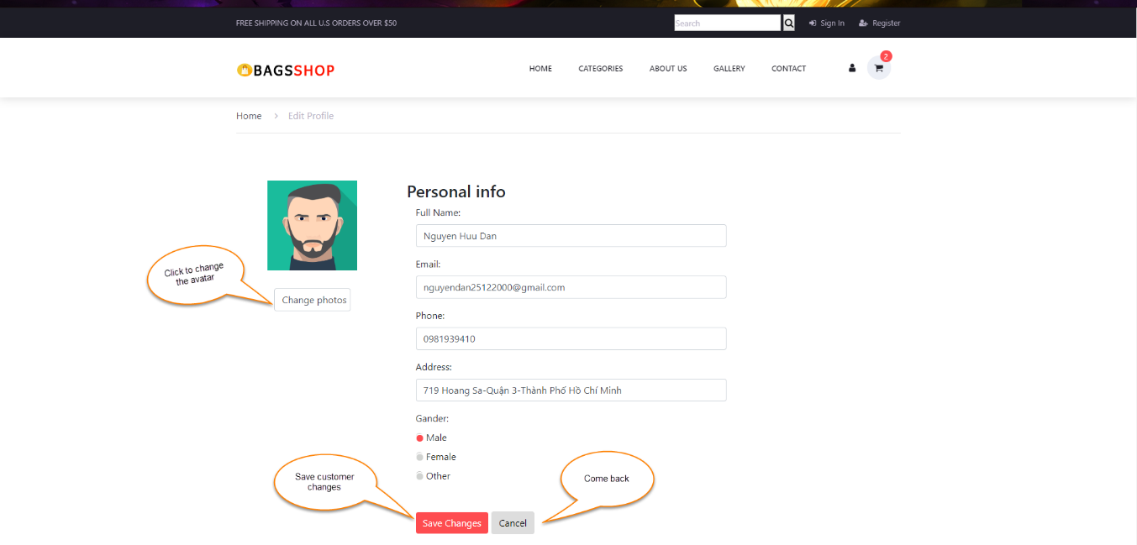

* **The Cart Page:**

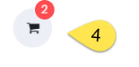: The products are selected by customers

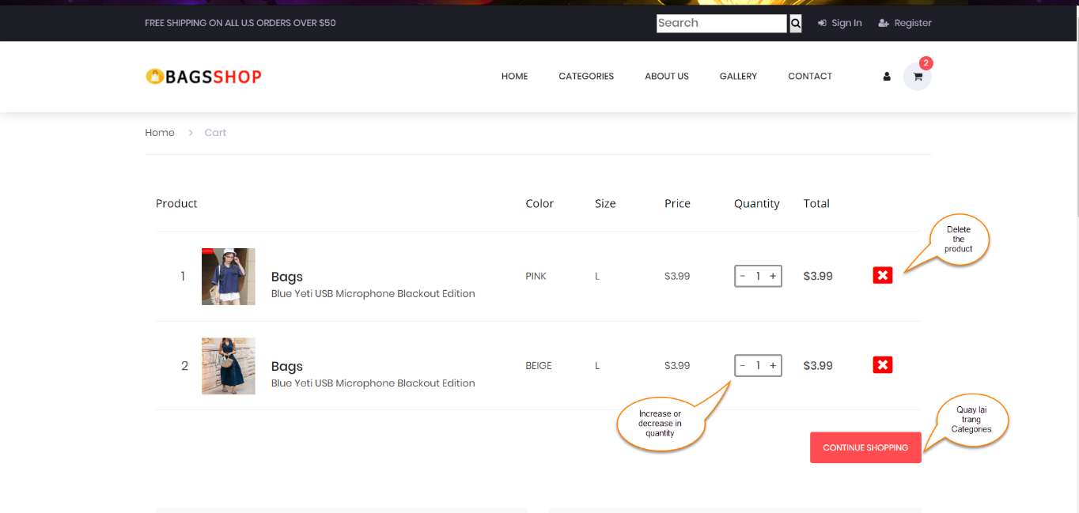

And:

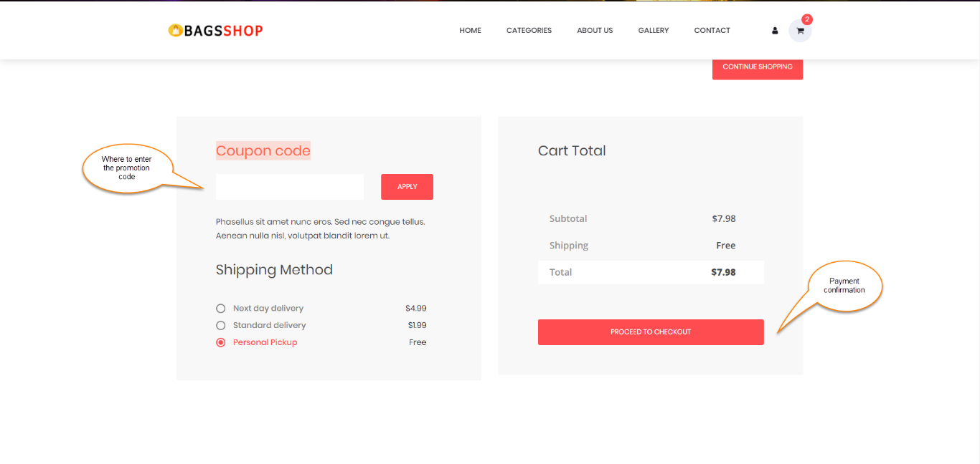

Customers can search for products by entering here:



And to return to the Home page, customers can click on the logo or shop name:



Customers can choose different types of products:

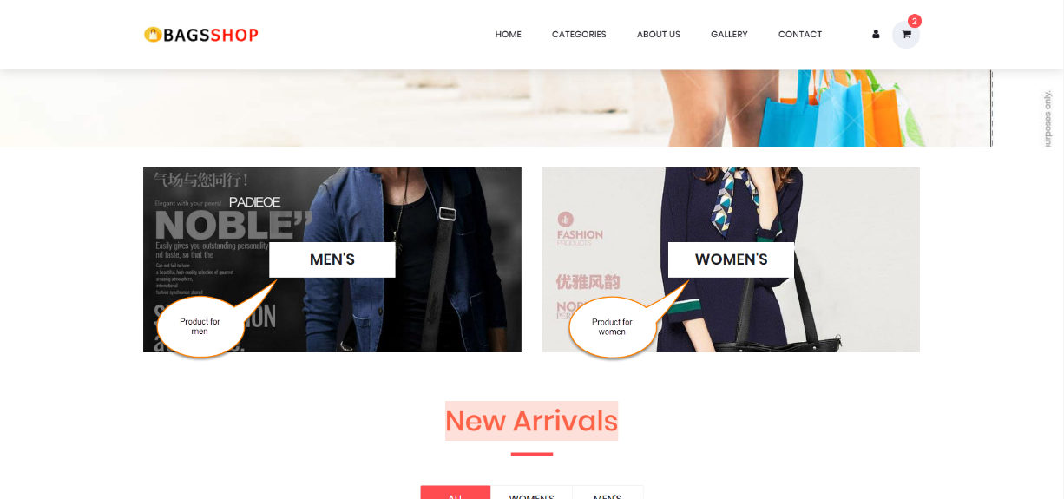

Customers can add products to the cart:

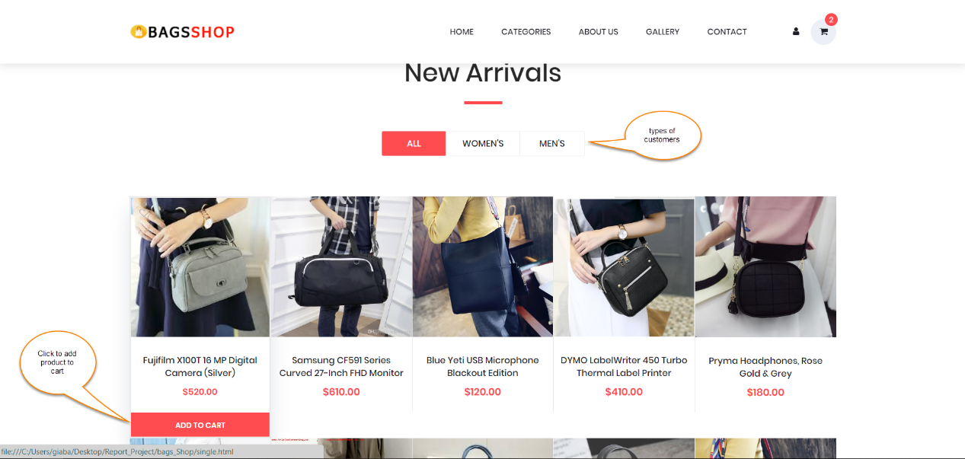

Customers can view the shop’s collection:

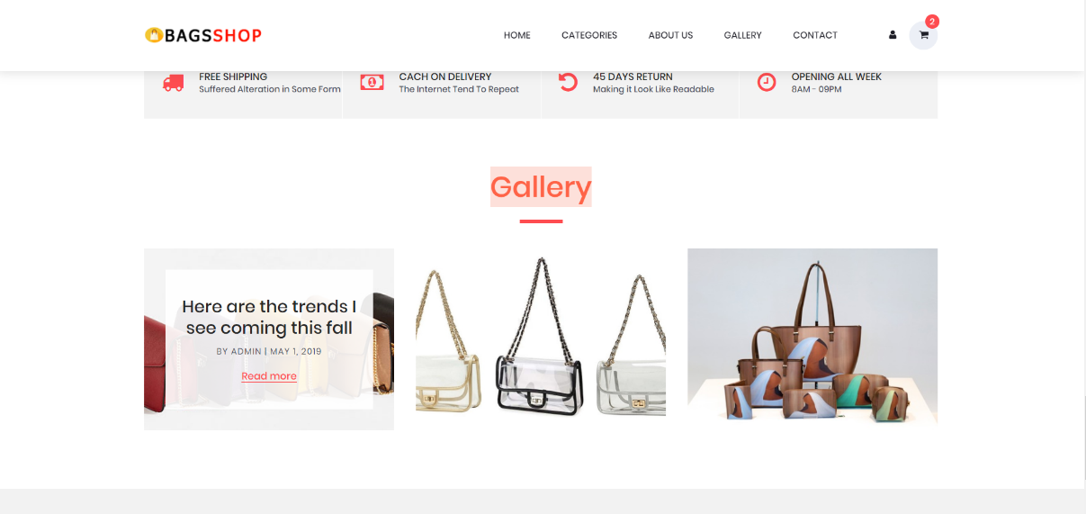

* **The Footer Page:**

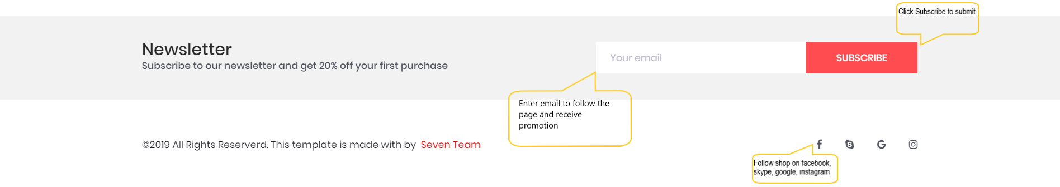

1. **The Categories Page:**
2. **Content:** The Home page of the website includes the following information:

* Display information of product, manufacturers, customer types

1. **Form:**

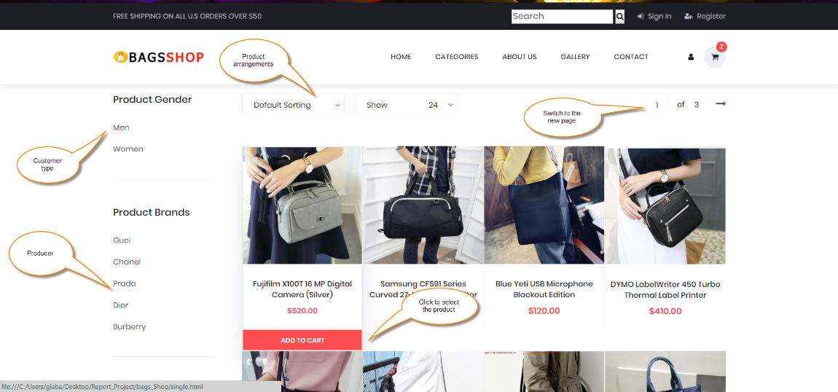

When user clicks on Add to card, the following page will appear:

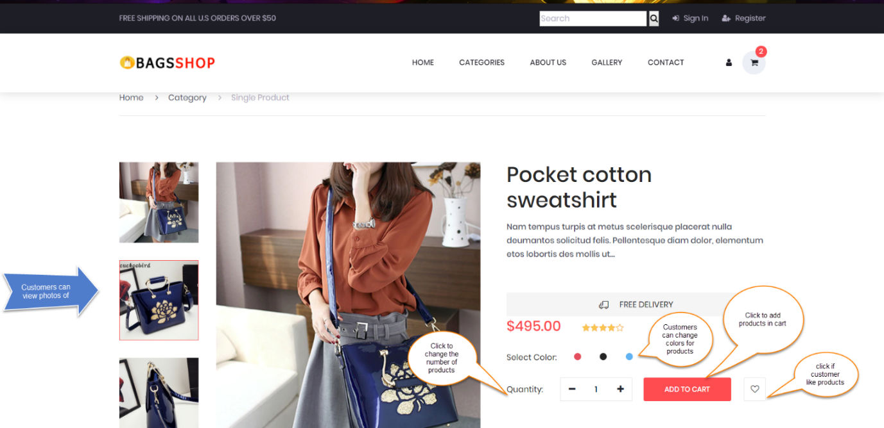

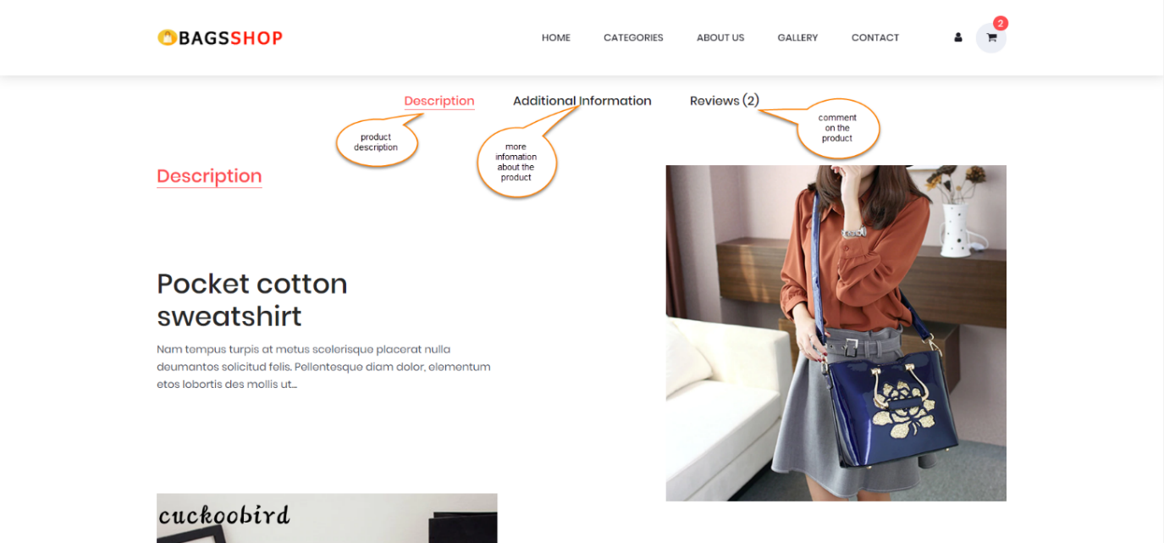And:

If user wants to comment on the product. They can click Review and do the following:

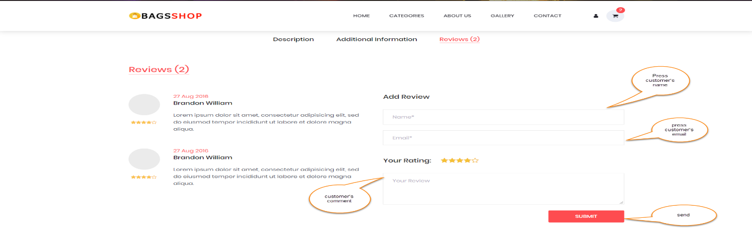

1. **The About Us Page:**
2. **Content:** The About Us page includes shop information, number of customers who visited and bought shop products. The page also shows shop collections.
3. **Form:**

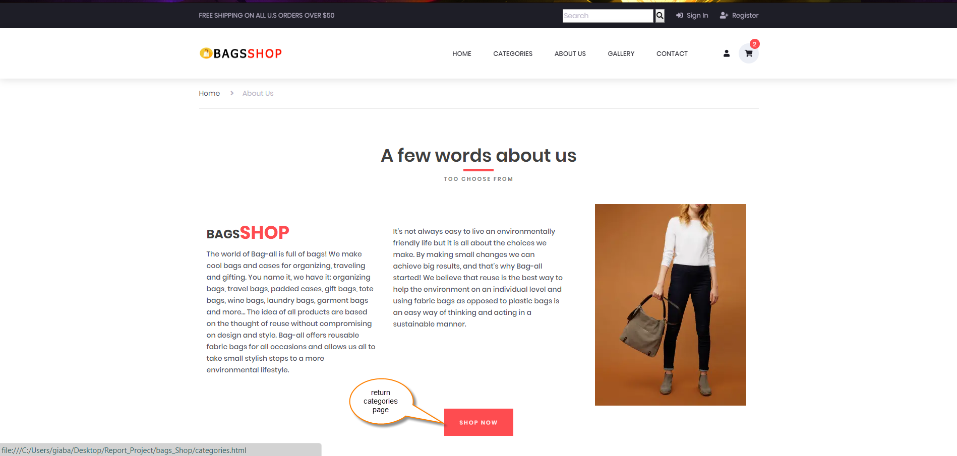

And:

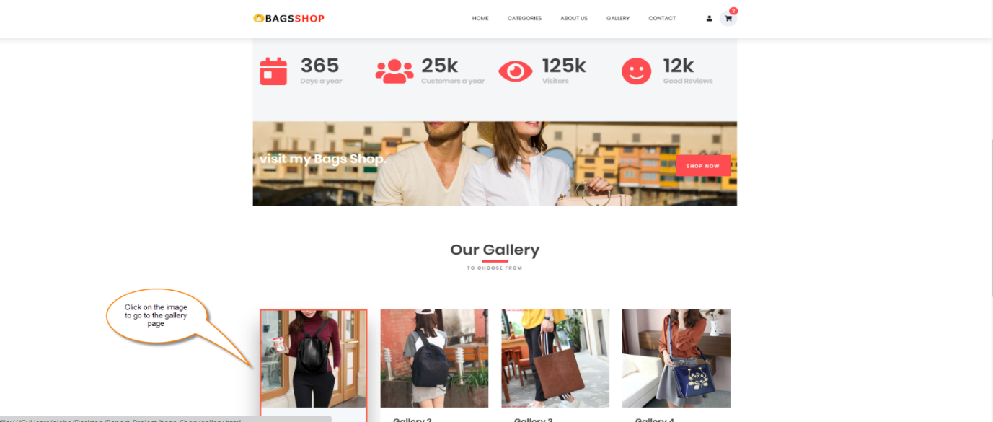

1. **The Gallery Page:**
2. **Content:** The Gallery Page contains detailed information about shop collections.
3. **Form:**

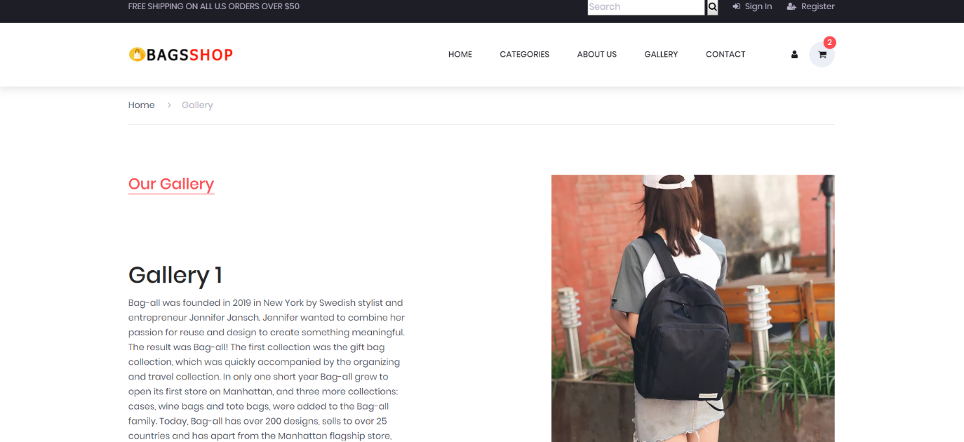

1. **The Contact Page:**
2. **Content:** This page will let customers know their location and nearby shops
3. **Form:**

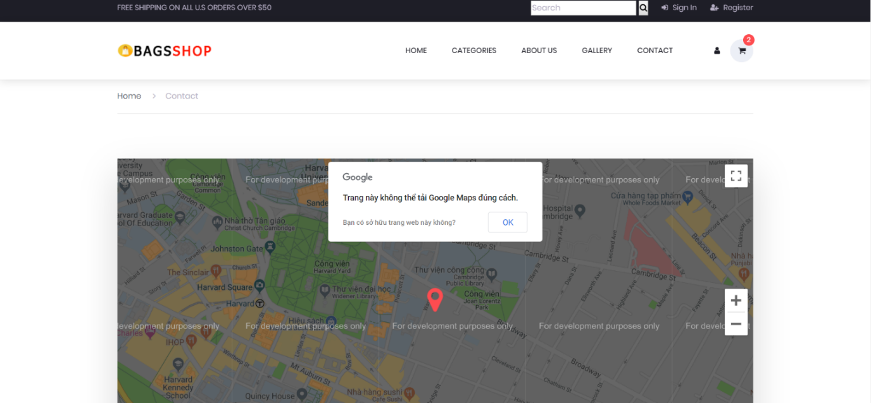

In this page, Customers can contact the shop via the phone number on this page or can email by entering the information in the form next to it: 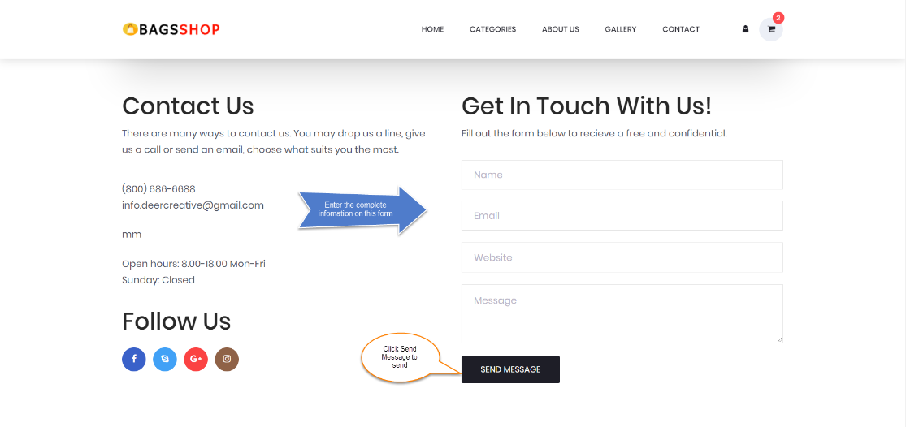

**CHAPTER VI: ADMIN GUIDE**

1. **Sitemap:**

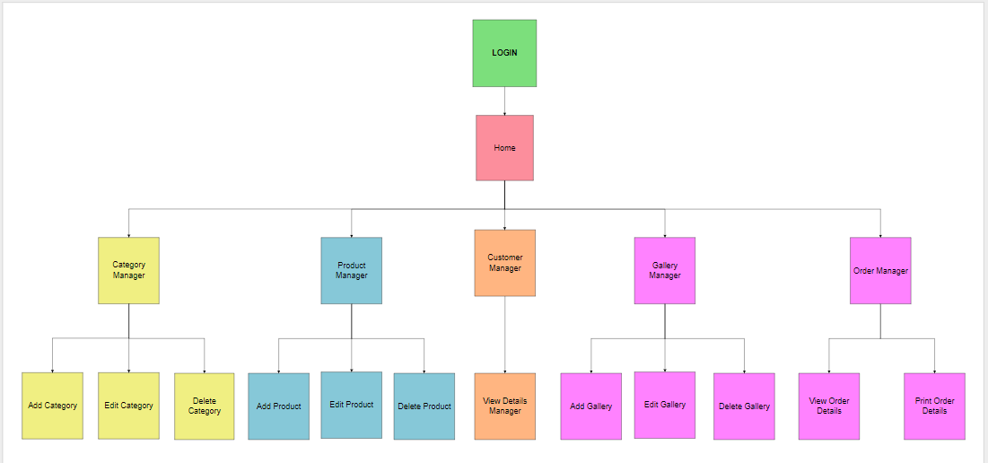

1. **Details of Pages**
2. **Page Login**

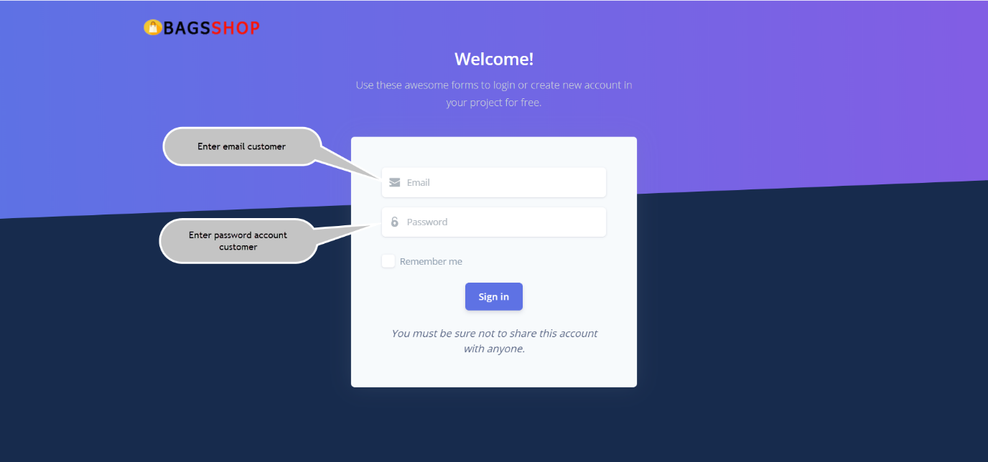

First, you will have to login with an admin account to be able to access the admin homepage.

1. **Page Home**

After you have successfully logged in, you will be redirected to the admin homepage. The following is a detailed description of the structure and function of each element on the page.

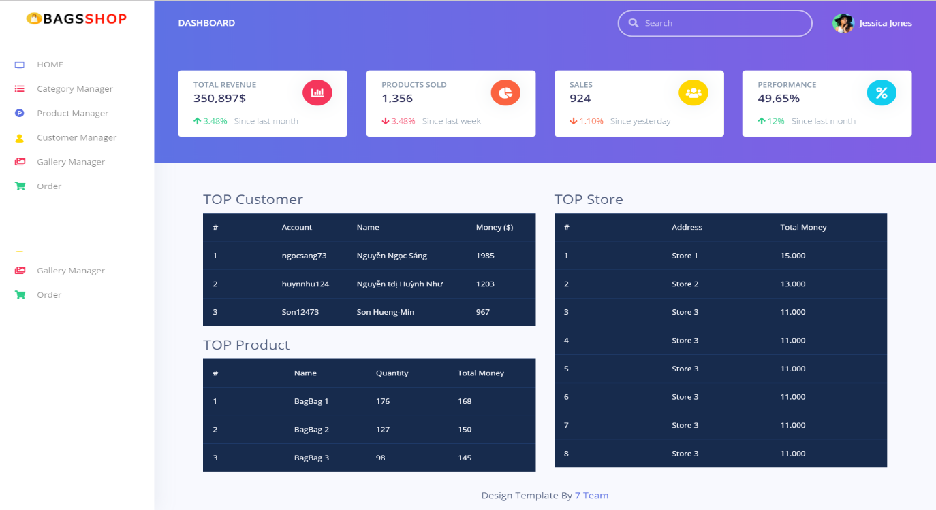Here, you can see some statistical tables such as: total revenue of a month, total number of products sold, total invoices, etc. In addition, there are TOP rankings that customers buy the most, TOP products are sold the most, TOP stores work the most.

1. Category Manager

* This is workspace : You can see name Catefory and edit,delete Category

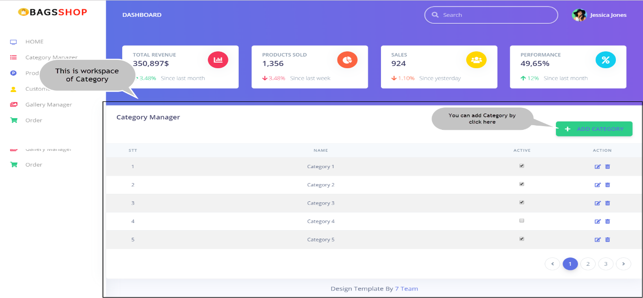

* This is where add Category:

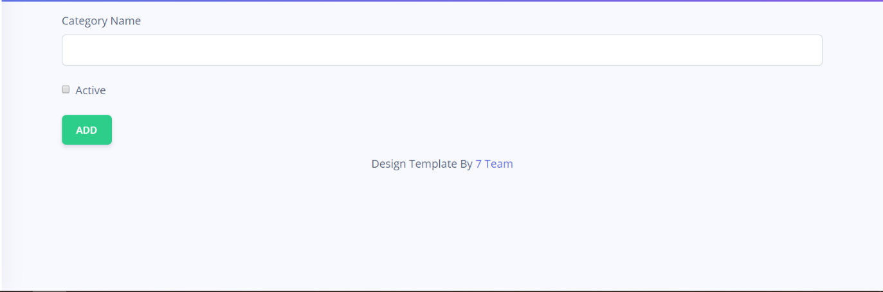

1. Products Manager

* This is workspace: Let’s show list information of product

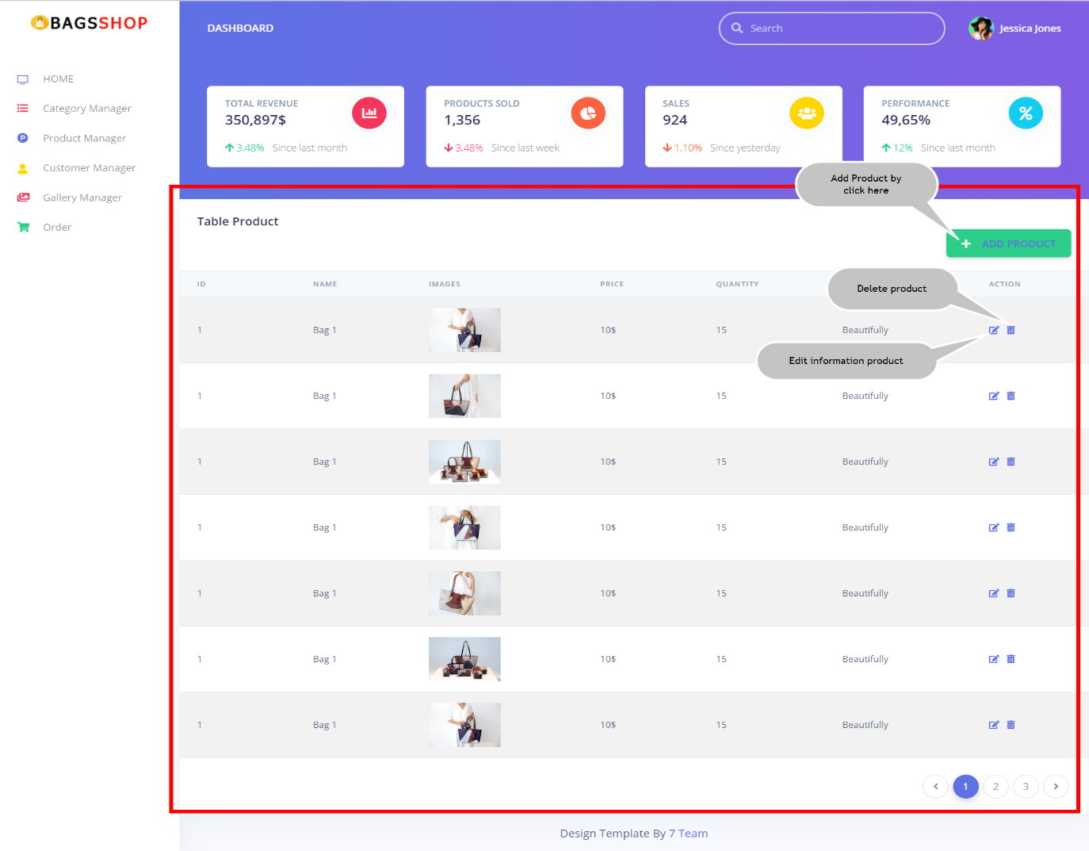

* This is where add products:

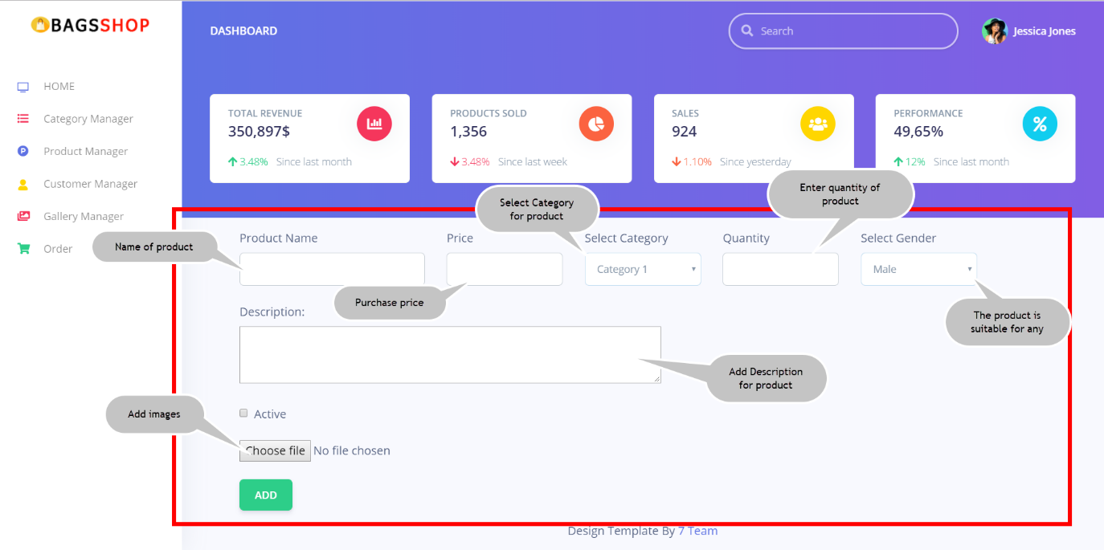

1. Customer Manager: Let’s show information basic of customer.

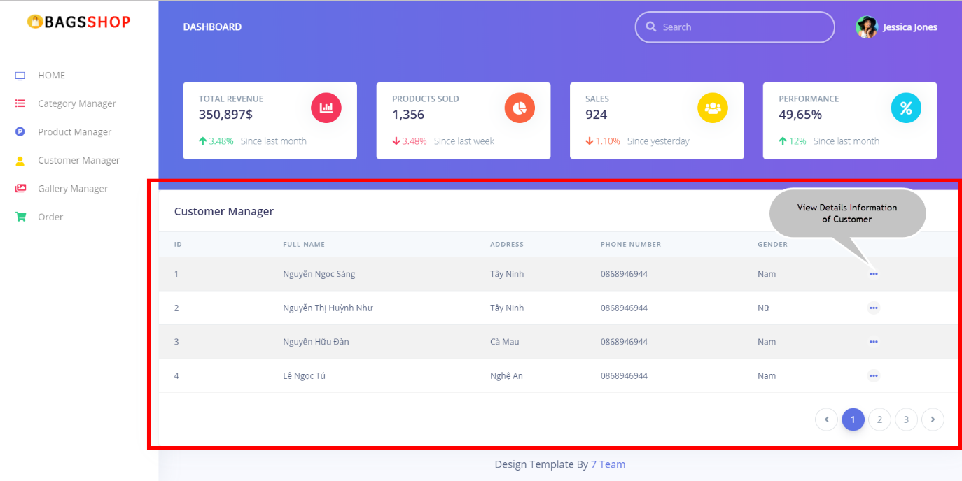

* You will see most information of Customer when click view details:

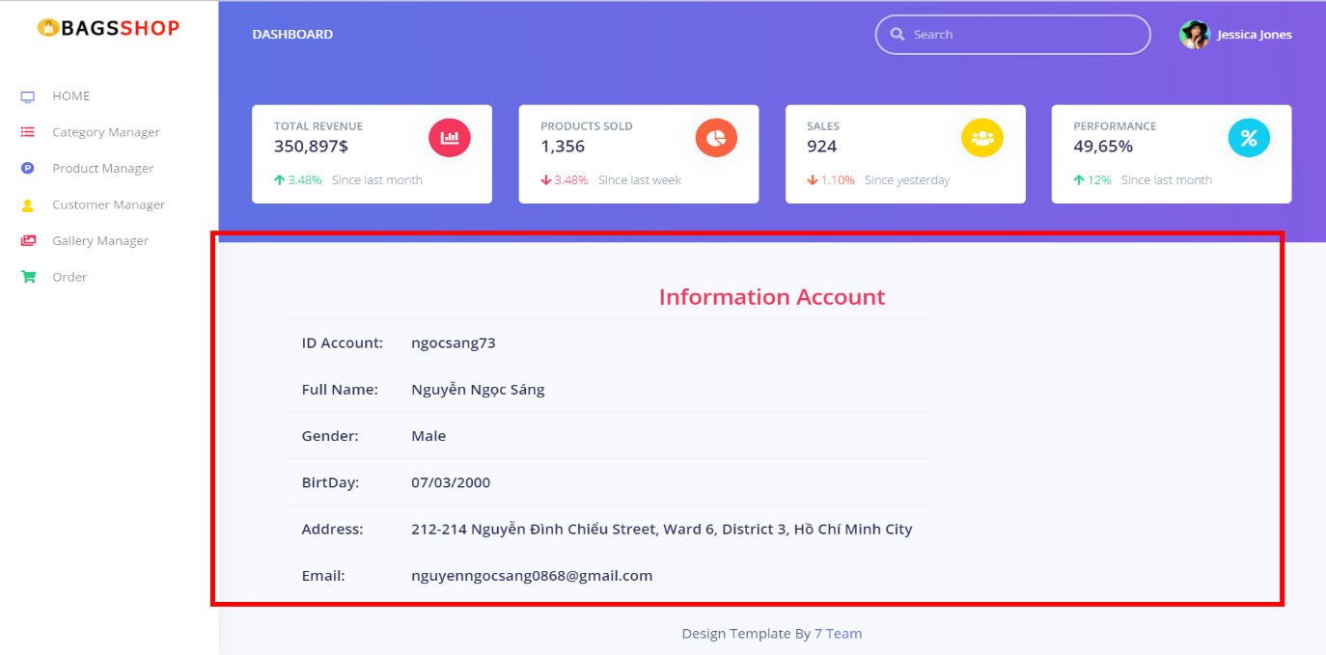

1. Gallery Manager: Let’s show name, image main and description of gallery.

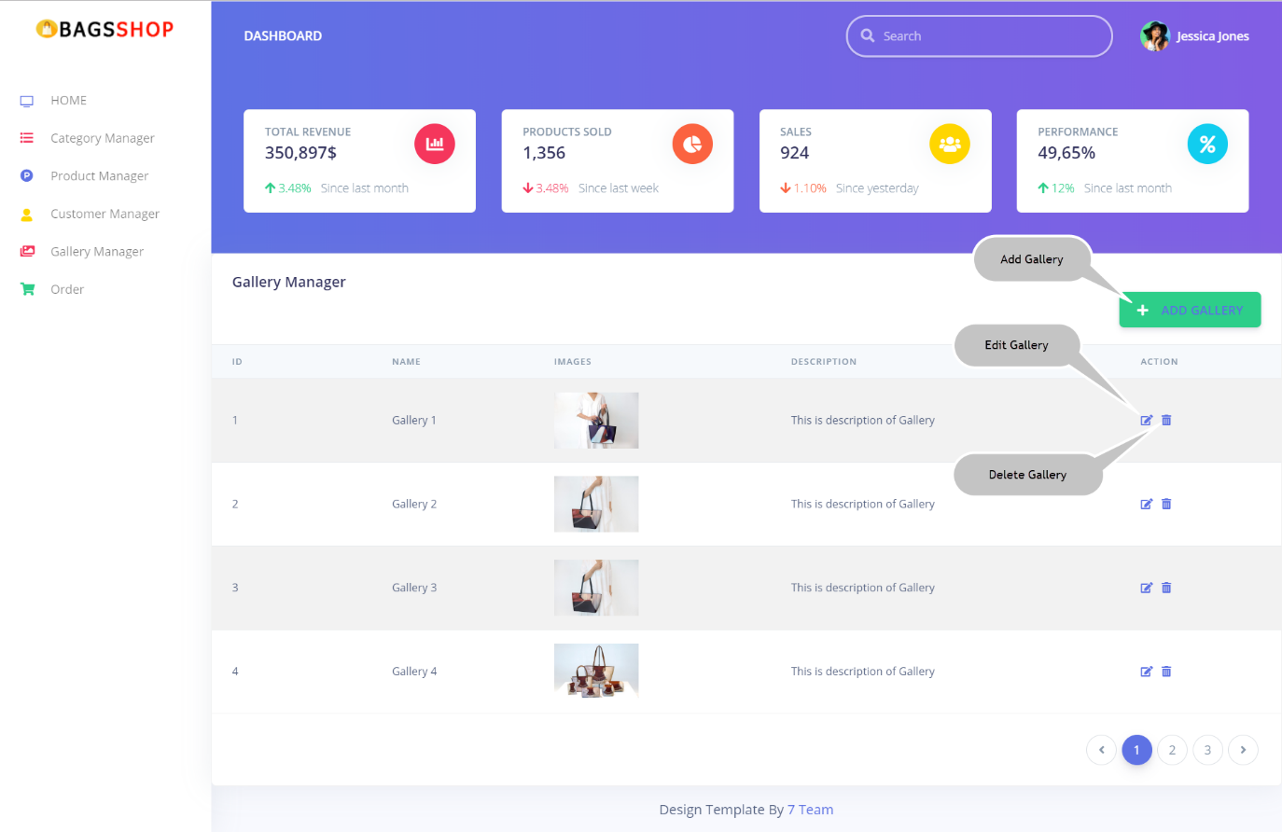

* Add Gallery here:

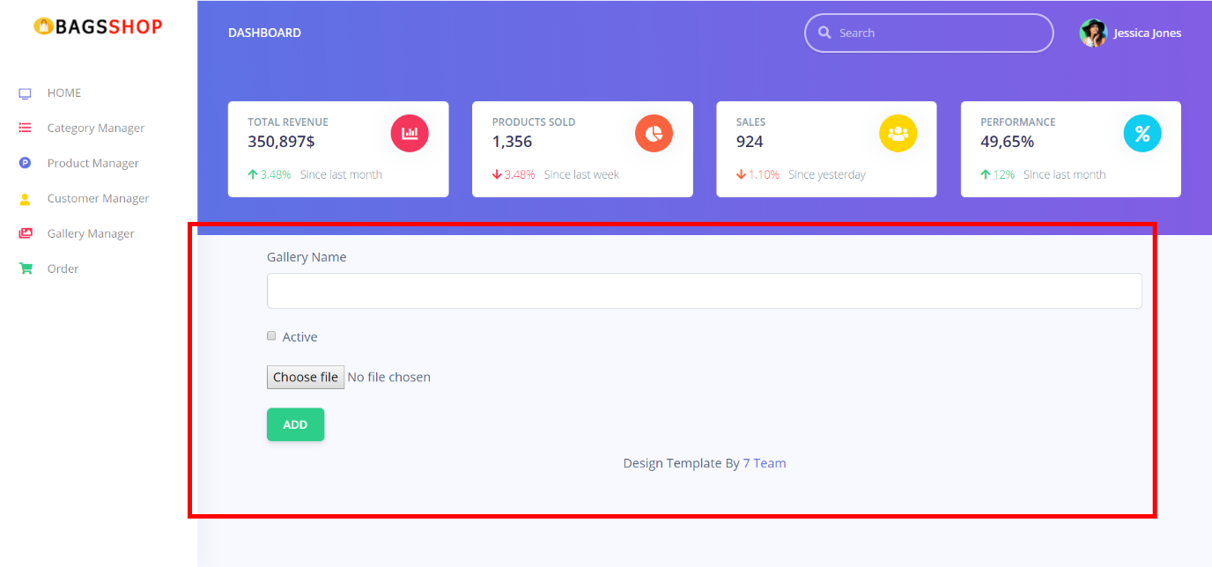

1. Order : You will see id customer, day create, total money and status of order.

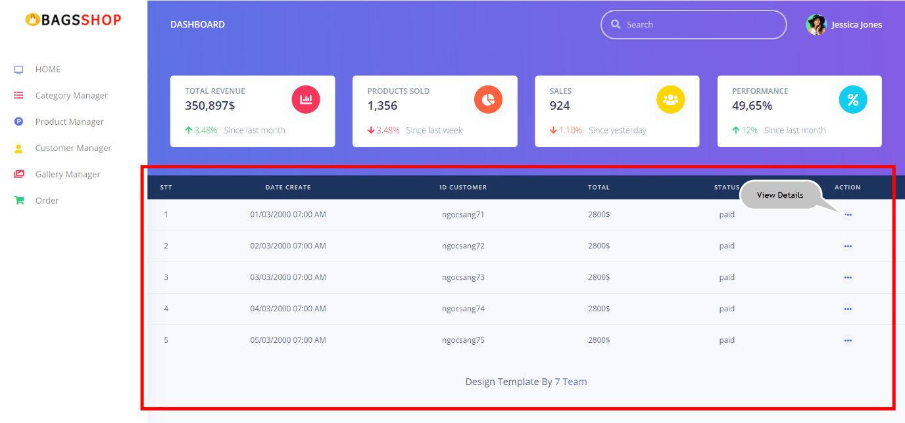

* View Details each order:

